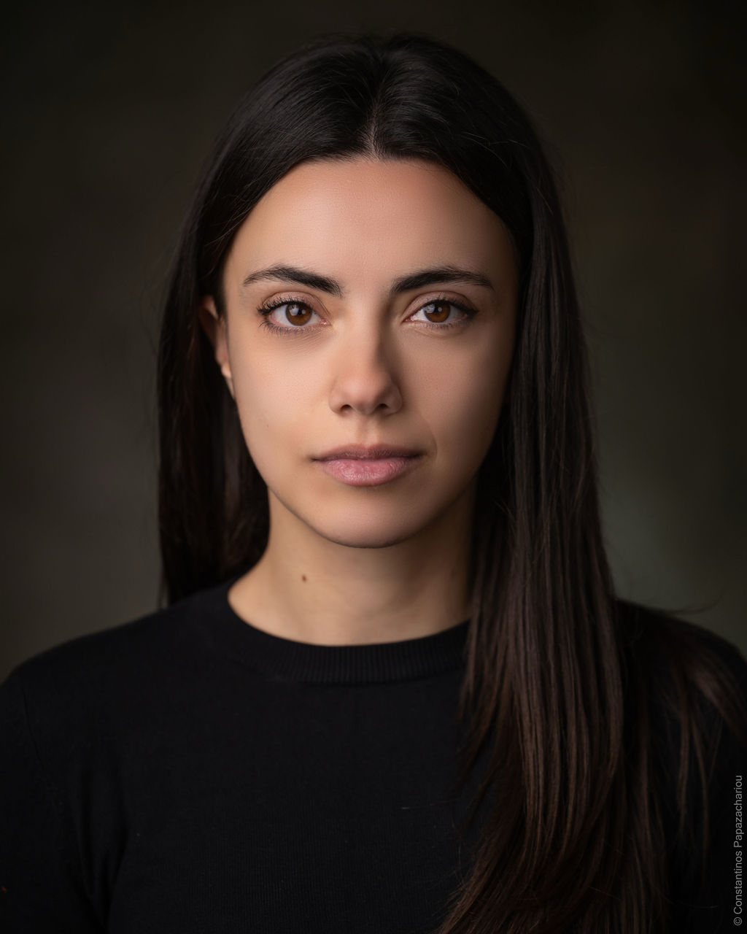


ZOE GERAZI

PERSONAL DETAILS
Phone: +30 697 020 6405
Email: zoerazi@hotmail.com
Nationality: Greek
Playing Age: 18–28
Height: 5’3” (160 cm)
Weight: 110 lbs (50 kg)
Hair: Dark Brown
Eye: Brown

TELEVISION
I Gi tis Elias (The Land of the Olive Tree) — Main Role: Eirini Kapernarou
Director: Andreas Georgiou | MEGA | 2022–2025
Cartes Postales — Guest Role: Lina
Director: Giorgos Papavasiliou | ERT | 2021

THEATRE
Petai Petai — Choulia, a Turkish air hostess
Theatre Psyrri Production | 2026–2027 / National Tour & Athens Season
Director: Vasia Panagopoulou

COMMERCIALS
Eurobank — Christmas Elf | 2020

EDUCATION & TRAINING
Theatre Performing Arts — Drama Centre UK
High School Diploma — 19th High School of Athens

LANGUAGES
Greek — Native
English — Fluent : Cambridge Lower Certificate
Michigan Lower Certificate
TOEIC Lower Certificate
Albanian — Fluent
Italian — Basic

ACCENTS
Greek — Native
British RP — Strong
General American — Strong
Albanian — Strong
Italian —- Basic

ACTING SKILLS
Camera Acting
Theatre Acting
Improvisation
Monologue Work
Character Development
Acting Technique
Movement for Actors

VOICE & VOCAL SKILLS
Musical Theatre Singing and Vocal Training
Voice & Speech Training

PHYSICAL SKILLS
Contemporary Dance (1 year)
Swimming (1 year)
Track & Field (1 year)
Pilates (2 years)
Stage Movement (6 months)

WORKSHOPS & ADDITIONAL TRAINING
Ongoing Private Acting Coaching — Marissa Triantafyllidou
Ongoing Musical Theatre Singing & Vocal Training — Nikos Roussakis
Voice & Speech Training Workshop — Ilias Kountis
Acting Workshop: Basic Principles, Movement, Monologues — Eleni Desylla
Acting Workshop: Ancient Greek and Modern Greek Theatre — Michalis Syriopoulos

